**A Report on**

**E-library**

## **By**

**Names of the students Enrolment No.**

Chandrakanth Kondeti 200347  
Manikanta Mandala 200335  
 Khushi Telugu 200400  
Nishita Namdeo 200416  
 Mathamsetty Krishna Akhil 200324

Prepared in the partial fulfilment of the

**Major Project-1**

Under Guidance of

# **Dr.Hirdesh Pharasi** (assistant professor)

**Dr Predeep Arya** (assistant professor)

**Dr. Satyendr Singh** (assistant professor)

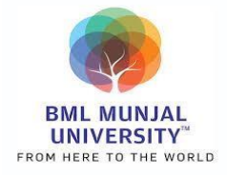

**Department of Computer Science and Engineering**

## **SCHOOL OF ENGINEERING AND TECHNOLOGY**

## **BML MUNJAL UNIVERSITY GURGAON-122413, INDIA**

# **MAY 2023**

|  |  |
| --- | --- |
|  | **BML MUNJAL UNIVERSITY, GURGAON**  **HARYANA** |

CANDIDATE’S DECLARATION

We hereby declare that the work done in my core project entitled **“Elibrary”** in fulfilment of completion of 6th semester of Bachelor of Technology (B. Tech) program in the Department of Computer Science and Engineering, BML Munjal University is an authentic record of my original work carried out under the guidance of **Dr.Hirdesh Pharasi**. Due acknowledgements have been made in the text of the project to all other materials used. This core project was done in full compliance with the requirements and constraints of the prescribed curriculum.

Place:

Date:

## Chandrakanth Kondeti

## 200347

## Manikanta Mandala

## 200335

## Khushi Telugu

## 200400

## Nishita Namdeo

## 200416

Akhil   
200324

**ABSTRACT**

The advent of the digital age has transformed the way we access and consume information. In recent years, the popularity of eLibraries has grown exponentially, making it possible for individuals to access vast amounts of knowledge and information from the comfort of their homes or offices. An eLibrary is a digital platform that provides access to electronic resources such as e-books, journals, research papers, and other educational materials.  
So we as a group felt like developing one such Elibrary website for our own college and we could successfully develop a website where there are two end one being the students side where they can use the website to get the knowledge .The second is the admin side where they will be having the editing rights i.e either Adding data/Contents to website or delete the data on the website.So the module which we worked on is the search engine.

This report provides an overview of the benefits of eLibraries and their impact on education, research, and society at large. We also explore the challenges and opportunities associated with eLibraries, including issues of accessibility, affordability, and digital literacy. Finally, we examine the future of eLibraries and the role they may play in shaping the future of learning and knowledge dissemination. Overall, this report highlights the importance of eLibraries as a valuable resource for learners and researchers worldwide, and the need for continued investment in their development and accessibility.

**ACKNOWLEDGEMENT**

It is with a deep sense of gratitude and reverence that we express our sincere thanks to everyone who helped us in this period to complete this project.

All the work that we have done successfully under them contributes to the success and outcome of this project.

We are highly grateful to Dr. Pradeep Arya, Associate Professor, BML Munjal University, Gurugram, for providing supervision.

Dr. Hirdesh Pharasi, Associate Professor has provided great help in carrying out this project and is acknowledged with reverential thanks. Without wise counsel and able guidance, it would have been impossible to complete the project in this manner.

We would like to express thanks profusely to Dr. Satyender Singh, Associate Professor for stimulating us from time to time. We would also like to thank the entire team at BML Munjal University. This acknowledgment will remain incomplete if we fail to express our deep sense of obligation to my parents and friends for their consistent blessings and encouragement.

**TABLE OF CONTENTS**

___________________________________________________________________________

Contents Page No. 

**Candidate’s Declaration 1**

**Abstract 2**

**Acknowledgment 3**

**List of Figures 5**

**List of Tables 6**

**Motivation 7**

1. Introduction to Project…………..…………………..…….………………….8

2. Problem Statement.………………………………….…….……………..…..9

4. Literature Review…………………………....................................................11

5. Methodology……………….………………………………….……………..19

6. Results and Discussion …………………………..…………….…………....24

7. Conclusion and Future Work…………………………………….…………..29

8. References…………………………...……………………….………….…..31

**LIST OF FIGURES**

**________________________________________________________________**

Figure No. Figure Description Page No.

**________________________________________________________________**

1. Architect of Project……………………….…24

2. Home Page………………………….……….25

3. Sign in page………………………………….26

4. Forgot Password Page………………………..26

5. Search Bar………………….……….………..26

6. Result of Searching…………...……….……..27

7. Book-Keeping Page………………..….….…..27

8. User Profile Page Sec 1……………………….27

9. User Profile Page Sec 2……………………….28

10. Virtual Tour…………………………………...29

**LIST OF TABLES**

___________________________________________________________________________

Table No Table Description Page No. ___________________________________________________________________________

1. List of Research Papers………………………………23

**MOTIVATION**

The motivation for doing a project on eLibrary is to provide an innovative and accessible way for people to access knowledge and information, while also providing an opportunity for libraries to innovate and adapt to the changing needs of their users.

There are several motivations for doing a project on eLibrary, such as:

**Accessibility:** eLibraries make resources available to anyone with an internet connection, regardless of their location or physical ability. This allows users to access resources that might not be available in their local area, or that they might not be able to physically access.

hi

**Convenience:** eLibraries are available 24/7, which allows users to access resources at any time that is convenient for them. This is particularly beneficial for individuals who have busy schedules or cannot visit a physical library during regular operating hours.

**Cost-effective:** eLibraries can be more cost-effective than traditional libraries as they don't require physical space, staff, and maintenance costs. This can make it easier for libraries to provide resources to more people without exceeding their budgets.

**Sustainability:** eLibraries can be more sustainable than traditional libraries because they don't require paper, printing, or shipping of physical materials. This helps to reduce carbon footprint and environmental impact.

**Innovation:** eLibraries provide an opportunity for libraries to innovate and experiment with new technologies and services, such as interactive e-books, audio-visual resources, and online learning platforms. This helps libraries to stay relevant and adapt to the changing needs of their users.

# **INTRODUCTION:**

A digital library is an online Database of digital items, such as text, images, audio files, and other types of digital media. Through interoperability and sustainability, these information retrieval systems can exchange information with one another.

In today's digital age, access to information has never been easier. The rise of the internet and advancements in technology have transformed the way we learn, research, and consume information. ELibraries have emerged as a popular platform that provides easy access to vast amounts of knowledge and information. An eLibrary is a digital library that enables users to access electronic resources such as e-books, journals, research papers, and other educational materials from anywhere in the world, at any time. This report aims to provide an overview of the eLibrary, its benefits, challenges, and future prospects.

The report begins by providing a brief history of eLibraries and their evolution over time. We then discuss the various types of eLibraries, the electronic resources they offer, and the benefits they provide to users. The report also delves into the impact of eLibraries on education, research, and society, highlighting their role in promoting learning and knowledge dissemination.

Moreover, we explore the challenges and opportunities associated with eLibraries, including issues of accessibility, affordability, and digital literacy. We discuss how eLibraries can help bridge the digital divide and improve access to information for underserved populations. Finally, the report concludes with an analysis of the future of eLibraries and the role they may play in shaping the future of learning and knowledge dissemination.

Overall, this report aims to provide a comprehensive understanding of eLibraries and their importance in today's digital age. It highlights the need for continued investment in their development and accessibility to ensure that everyone has access to the knowledge and resources they need to succeed.

# 

# 

1. **PROBLEM STATEMENT**

* **Issues we are facing**

College students often face difficulties accessing and utilizing physical library resources due to factors such as limited opening hours, limited availability of resources, and the need to physically visit the library. Additionally, the shift towards digital learning has highlighted the need for a user-friendly and comprehensive e-library platform that provides access to high-quality and diverse digital resources.

Therefore, there is a need to develop an e-library platform for college students that addresses the challenges of access and usability, while also providing a wide range of digital content that caters to the needs of various academic disciplines. The platform should also incorporate features that enable collaboration, resource sharing, and knowledge dissemination among students and faculty members. Additionally, it should be accessible on various devices and provide a personalized user experience that promotes engagement and learning.

* **Problems we are Addressing**

In our project we are focussing on the following problems :

**Search Engine:** We are integrating the search engine with the E-library's classification and indexing systems to provide a comprehensive and intuitive user experience. It would be able to filter the user search requests according to book title, author, publication etc.

**E-books:** Our aim is to make the books available for students whenever they want to access it that's why a soft copy of the book which is present in the physical library will be available on the website.

**Book Issue and Return:** Students would be able to see when they issued a particular book and when is the return date.

* **How the Problem is Solved**

In our E-Library project we have built a user-friendly website. The above listed problems will be solved in the following manner.

**Search Engine:** The integration of a search engine with the e-library's classification and indexing systems will enable users to find the resources they need quickly and easily. Users can filter their search requests according to book title, author, publication, and other relevant criteria. The search engine will provide a comprehensive and intuitive user experience.

**E-books:** Making books available in soft copies on the website will provide students with anytime, anywhere access to the resources they need. This feature will eliminate the need for students to visit the physical library to borrow or read books, which can be time-consuming and inconvenient.

**Book Issue and Return**: The website will provide students with information about the books they have borrowed, including when they issued a particular book and when the return date is. This feature will help students keep track of their borrowing history and avoid overdue fees.

# **3. LITERATURE REVIEW:**

3.1 Existing E-libraries Management systems:

There are various E-Library Management systems available, which include digital asset management system, open-source library systems. These systems help build libraries easily. An open-source library management system in koha library management system which is used by our library catalogue website.

3.2 Library websites:

As our project is product based. We have done a product based literature review. We reviewed 10 top QZ ranking library websites. Here are those observations

|  |  |  |
| --- | --- | --- |
| **S.no** | **Name of the**  **Institution** | **Observations** |
| 1 | Massachusetts Institute of Technology (MIT) | MIT has a simple yet distinctive UI with interesting features like voice search which is not quite common among e-libraries. The entire website pleasant on eyes and the usability of buttons is also pretty easy. The website consists of Live feature and saved items feature. Here one of the difficult things is Login.Here it is Pretty difficult to find the login page. Here as the website consists of too many resources it is hard to navigate and the access is also limited. |
| 2 | Stanford University | The e-library of Stanford University is a comprehensive digital library that provides access to a wide range of electronic resources, along with other academic libraries make it a valuable resource for researchers worldwide. The e-library's user-friendly interface and online reference services also make it highly accessible and easy to use. This website has little issue of padding as the space above the nav bar makes it unusual to see and the colour theme of the website is based on the logo of the university. Here all the information of the library in the navigation and the body of the website has the research and catalogues with library hours. |
| 3 | University of Cambridge | The University of Cambridge has a long history of providing library services to its students and faculty. The library was established in the 14th century.The e-library is established in 1990.The e-library system at Cambridge provides training and support for Students and Researchers across the world, including workshops and tutorials on how to use electronic resources effectively.Here the nav bar includes search bar which different from some websites. |
| 4 | Oxford University | The E-library of Oxford university is pretty similar to the E-library of the MIT.Here the library has restricted access towards the information in the website. The platform offers a variety of search options that allow users to find information quickly and efficiently.here also the website consists of live chat feature. Choosing of a study space according to selected preferences features.The interface is user-friendly.The colour pattern is according to the logo but the look of the website is stale. Here the body of the website contains the details of the digital library with the information about the services and infrastructure. |
| 5 | Harvard University | The E-library of Harvard has a vast collection of books, journals, and articles.that the e-library was critical in facilitating research activities and providing quick access to scholarly resources.here the e-library's advanced search functionalities and customized alert services enabled researchers to stay up-to-date with the latest publications in their respective fields.  This website has used four major colours in which 3 are from the logo. The navigation bar and body of the website have nearly the same required items but in the body of the website they have also included how to use the website which improves the usability of the website. |
| 6 | University of Pennsylvania | The colour palette of the entire website is inspired from the colours present in the logo.Here we can see that they have used different buttons for catalogue and website searches.The website consists of a easy start guide which helps in improvement of the usability.Here the website is easy to use but they have included too many things on the home page.So, there is too much scrolling and the text size is big with too much space between the elements in the website. |
| 7 | Notre Dame University Hesburgh Library | This library also follows the trend of using the colour palette of the logo.One search bar for all kinds of searches.Upon entering the library you will feel that the website is bit of congested.Here the navigation bar is static and they made a good use of logos.If we keep aside the congested feeling of the website it is well-mainted of the objects which are present in the website. |
| 8 | Ithaca college | The website is too simple with very less features and unusual colour patterns. The ux is pretty difficult to understand and they include most of their features in the footer rather than the navigation bar which results in thinking that the website has very less features.Here also the one search bar for all searches trend is followed. The resources of the library are not easily available and most of them are restricted . |
| 9 | Caltech library | The colour palette of the website is pretty inspiring as they have not used the colours of the logo,They went with the best possible colours according to their research and made the website with a peaceful UI. They included more features in the available space. They gave quick links for easier and more time efficient search. |
| 10 | IIT Delhi | Here the Users can keep track of their borrowing history, fines, and renewals. Users can request resources that are not available in the IIT Delhi library but can be borrowed from other institutions. Users can ask librarians for assistance with research or finding specific resources. Reminders for due dates and new additions to the library's collection.The website is mobile-friendly. The library also supports advanced searches which optimises the search processes. The design is user-friendly with navbar containing adequate amounts of features. |
| 11 | IIT Bombay | The homepage is very simple,relevant and to the point. Normally it is an average website but the UI of the website uses Dark grey,blue and white which creates a overall look of a old and unappealing look.But here The website has a FAQ section where you can get the answers of the most common questions.A-Z search bar on the top of the e-journals and e-books section.The search is very user friendly, there are so many sorting buttons which makes searching easy for users.So, th overall here the features are good and executed to the point but the UI is not so great which may reduce the usability of the website. |
| 12 | IIT Madras | Loved the way the website opens - It gives an illusion of entering a physical library through doors.More of an informative website for their physical libraryAdditional terms search barGives information about where the book is located and how many copies are availableWe can decide how many results we want in a pageThere is a sorting button, we can sort the results of our search by , date of publication(newest first / oldest first), author, call no., creation date, recently added items first, relevance and title.When you click on the title of a book it lands on google books, where you can see the book reviews. You can also buy that book from there. |
| 13 | IIT kanpur | The UI is very good (Color palette - Teal, sea green, white and navy blue).It is appealing to eyes and very smooth to work .Well-maintained website.It has a separate news update scrolling bar, where you can read the current news.Rest all features are same as IIT Delhi one. It is a very interactive design with well organised features . |
| 14 | IIT kharagpur | The color palette of a website can have a significant impact on its overall look and feel. In this particular case, the website uses a light blue and white color scheme, but the UI is not up to the mark. Different types of fonts are used and there is no specific color scheme followed, resulting in a lack of visual consistency. The home page is cluttered, and there is too much text with few visual elements. However, the website does have a column for visitor count from different countries and offers similar library features to those found in IIT Delhi. |
| 15 | Library of America | The UI is simple and good looking.Easy to use.Good in mobile mode also.Material is good no results page is bad.Footer details help a lot.Easy to navigate.Few pictures are big.Simple colour palette. At the end of the website they gave the signup for Newsletter and catalogue which is very tactical and good use of space as it is at the end of the website it is not disturbing the concentration of the user in finding his desired resources and when it is located at the end the user must have explored the entire website and is open-minded to the see new features. This promotes their advertisement and will not disturb the users attention but will gain the attention. |
| 16 | The Seattle Public Library | The Designing is good and very creative.Bit more time taking but appears to be worth the time . Responsive page which appearance is good in both mobile and also pc .Yes the latest content is available.Home page is not well organised which may cause in losing the attention of the user .Navigation is easier and text model is not stylish.More pictures are used which increases the usability and develops more interactions with the user .More colours used which may be a good thing in some place but not here. It doesn’t appear to be appealing to the eye. Except for the appearance of the main page most of the features are useful and user friendly but it needs more understanding time. This may work if they had provided any guide on how the website should be used. |
| 17 | California State Library | Design is simple and not much functionality.Simple to use. Here they didn’t follow the routine trend of using the colours in the logo . Even the logo contains dark colours and if we use the colours in the logo only then it may create an unusual website interface .Text is congested but the Good content and links makes up for the overall impression of the user .Text style not pleasant in few areas . Easy to navigate.Pictures are big in size when compared to the text assigned to the pictures. |
| 18 | Public library Brookline | Design and functionality are very good.Little tricky to use.Good in mobile mode also.The material provided is good.Search result page text is not that good but the home page is nice.The navigation is a little complex compared to the other websites.In homepage pictures used are good but in the other pages they are not.The colour scheme is very good. Here in the tutorials section the overall impression is not so great as they can make it better understanding and easy so that the usability of the website will increase. |
| 19 | Carnegie Library of Pittsburgh | UI is unique for this website compared to other websites.The icons are very nice and userfriendly.All the important functions such as searching for a book or learning from the research papers is very easy to navigate.One of the most impressive aspects of the website is the variety of services offered, including e-resources, digital media, and access to library materials. The website also includes information about library events, programs, and services, making it a comprehensive resource for users.  The website's design is clean and modern, with a pleasing colour palette and typography that is easy to read. The use of images and graphics is also effective, helping to break up text and make the website more visually appealing. |

# 

# **4. METHODOLOGY**

4.1. Explain the methodology:

Searching:

Define the search criteria: Before you start coding, determine the criteria that users will be searching for in your website . For example, you might want to allow users to search by Author, titles, ISBN, Call Number, Subject.

1. Create a basic User Interface for search and the navigation.
2. Set up your Node.js project: Create a new Node.js project and install the necessary modules (e.g. Express, Mongoose, etc.). Ensure your project is configured to connect to your MongoDB database.
3. Create a MongoDB collection: Assuming you don't already have a collection that contains the data you want to search, create one. Use the MongoDB shell or a MongoDB GUI tool to create a new collection and insert some sample data.
4. Define the search route: Create a new route in your Express app that will handle search requests. This route should accept search parameters (e.g. query string or form data) and use Mongoose to perform a search query on your MongoDB collection.
5. Construct the search query: In your search route, use Mongoose to construct a query object based on the search parameters provided by the user. You can use Mongoose's query building methods (e.g. where, regex, etc.) to construct the query.
6. Execute the search query: Once the query has been constructed, execute it against the MongoDB collection using Mongoose's find method. This will return a set of documents that match the search criteria.
7. Render the report: Once you have formatted the search results, render them using an EJS template or another templating engine. Loop through the results and display the relevant data to the user.

**Books-keeping :**

Define the books keeping criteria: Now first we have to define the criteria of what the book keeping means in the website . On what credential basics the admin will issue the book and enter the data in the website.

1. We create a UI for a data entry table and we define the columns in which we enter the data - “Roll no”,” Name” and “Book code”. Here every book is given an unique code according to the genre of the book
2. Creating another collection for the entries which are given by the admin.
3. Use the MongoDB driver to write a query to retrieve the book issue data from your database. Store the retrieved data in an array variable in your JavaScript code.
4. Loop through the book issue array. For each book issue object, create a new row in the HTML table and add cells for each column. Populate each cell with the corresponding book issue data from the object. Add a "Delete" button in each row that allows admin to delete the book issue from the database. Add the completed row to the HTML table.
5. Create a form for adding new book issue data to the database. Write a query using the MongoDB driver to insert the new book issue data into the database when the form is submitted. Store the timestamp of the issue in the database as well. Add event listeners to the table to allow users to delete existing book issue data. Write queries using the MongoDB driver to delete book issue data from the database when users click the "Delete" button. Update the table display to reflect any changes made to the book issue data in the database.

4.2. List the Technical features and Elements of the project:

Elements of Searching:

1. Search Form: A search form is the main element of the search feature that allows users to enter search queries. It should contain one or more input fields and a submit button.
2. Search query processing: When the user submits a search query, the application should process the query and return relevant results. This involves querying the MongoDB database using the Mongoose library and filtering the results based on the user's search query.

Technical Stack:

Developing a ELibrary system requires a frontend where the client will be interacting with the server, a backend where all the business logic would be stored and a database to store all the information related to users, Books, role of the user, posts, pdfs etc..

Frontend:

* HTML: It is the standard markup language used to create web pages.
* CSS: It is for styling the web page.
* JavaScript: It is a programming language which is used to give the dynamicity to a website.
* EJS:A templating engine for JavaScript used to generate HTML markup dynamically on the server-side

Backend:

* Node Js is a javascript runtime environment used to run code outside the browser.
* ExpressJs is a popular Node Js framework for creating REST API’s.
* MongoDB a NoSQL database for querying and storing data.
* Mongoose module for interacting with the database.

4.3. Draw the block diagram of your project:

Our project used MVC Architecture. It is the most famous architecture in web development. Where it stands for Model Views Controller architecture.

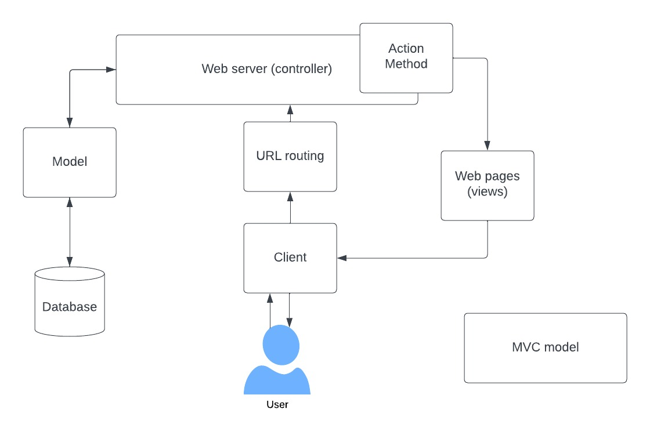

Fig1: Architecture of the project.

MVC (Model-View-Controller) architecture is a design pattern commonly used in software engineering, particularly for web applications. The MVC pattern is designed to separate the application's data, user interface, and control logic into three distinct components, providing a modular and maintainable approach to software development.

4.4. List all the components (hardware and software used in your project):

Softwares:

* VS-Code
* Terminal
* Studio 3T
* Postman/ web browser

4.5 Challenges faced:

When developing a project, it's common to encounter new technologies and concepts that require learning and experimentation. In our case, we faced this challenge while working on implementing features such as searching through databases and loading dynamic web pages using Node.js, ejs, MongoDB, and Express. These technologies are powerful and widely used, but they can also be daunting for newcomers.

To overcome this challenge, we adopted a structured approach to learning. We spent time researching and reading about each technology and its related concepts. We followed tutorials and examples to gain hands-on experience with the tools and concepts involved. We also collaborated with our peers, sharing knowledge and helping each other solve problems.

Through this learning process, we gained valuable insights into the workings of these technologies and their potential applications. We were able to implement the required features, and in doing so, we deepened our understanding of web development and expanded our skillset. Overall, this project taught us the importance of continuous learning and the rewards that come with pushing our boundaries and exploring new areas of expertise.

# 

# **5. RESULTS AND DISCUSSION**

The entire library website project has been divided into different modules and then each group got their own modules to work on.

So for our group we were assigned to work on the search engine.

Where the search algorithm will give the related materials details which are stored in the database.

Home page:

This is the home page of the project where users should be redirected to after signing in.

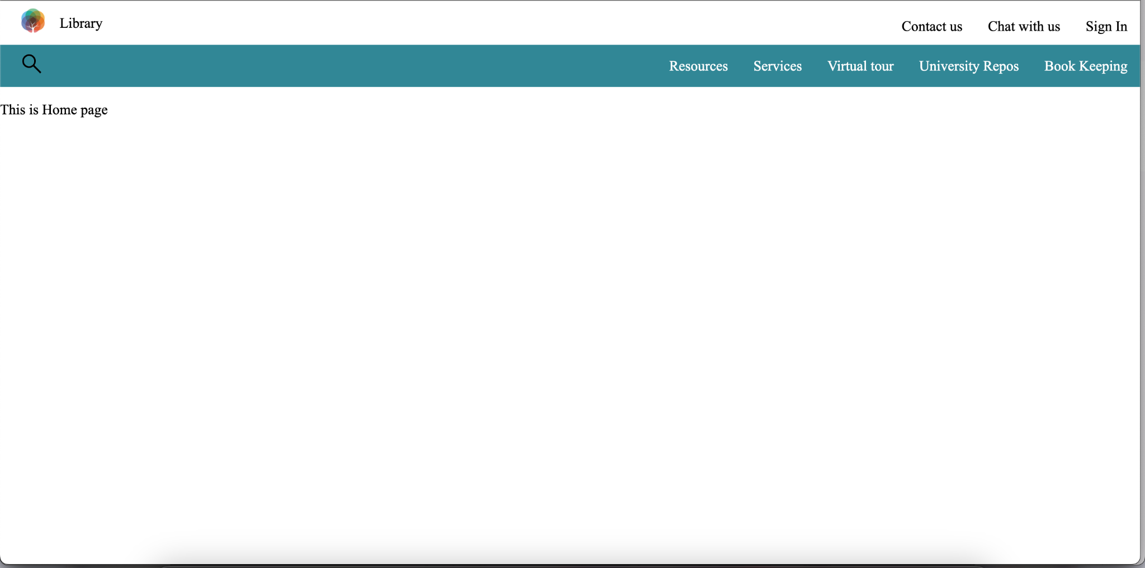

Fig 2: Home page

Signing In page: This is a page where the user should sign in to the website.

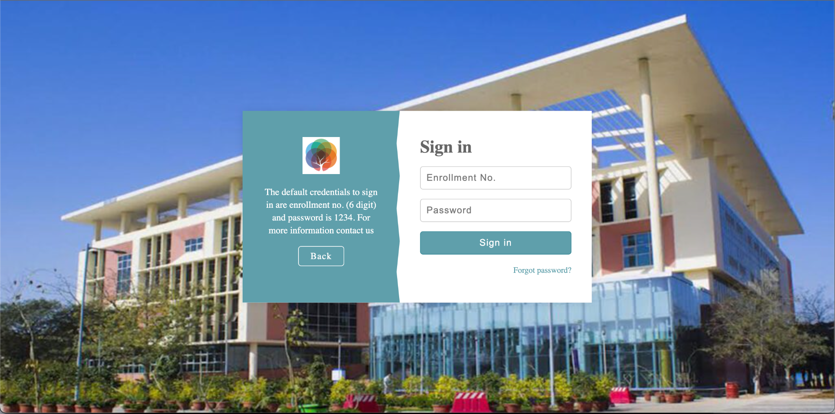

Fig3: Sign in page

Forgot password page : This is the forgot password page that should be implemented.

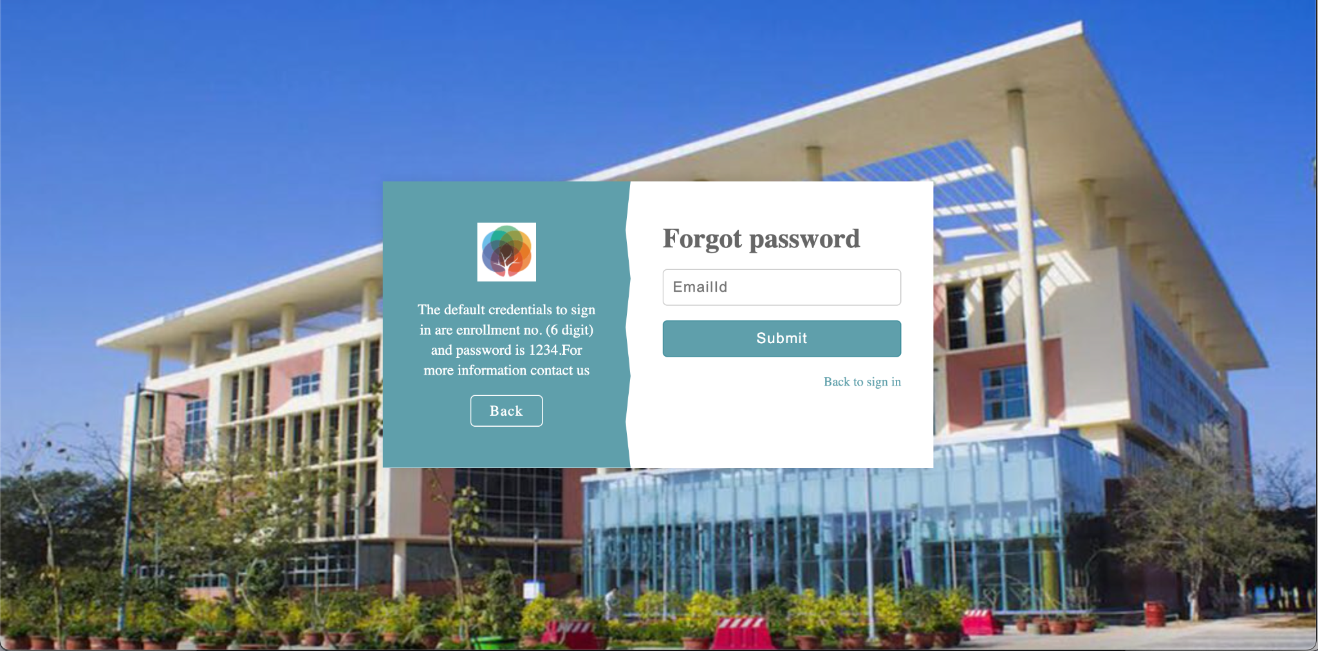

Fig4: Forgot password page

Searching through filtering via options provided(Library catalog, Title, Author Subject, Call number,etc..)

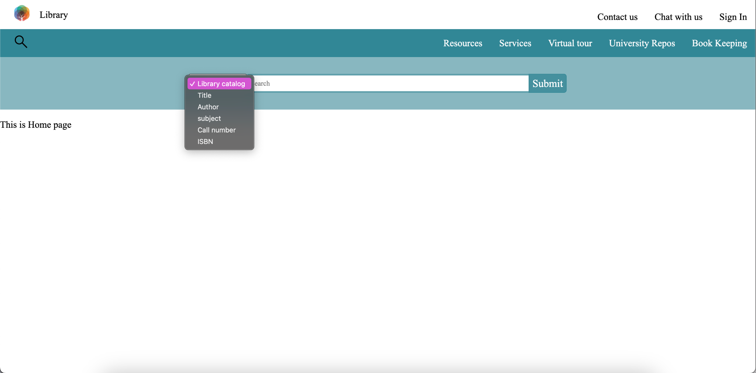

Fig5: Search bar

This is the resultant page after the search.

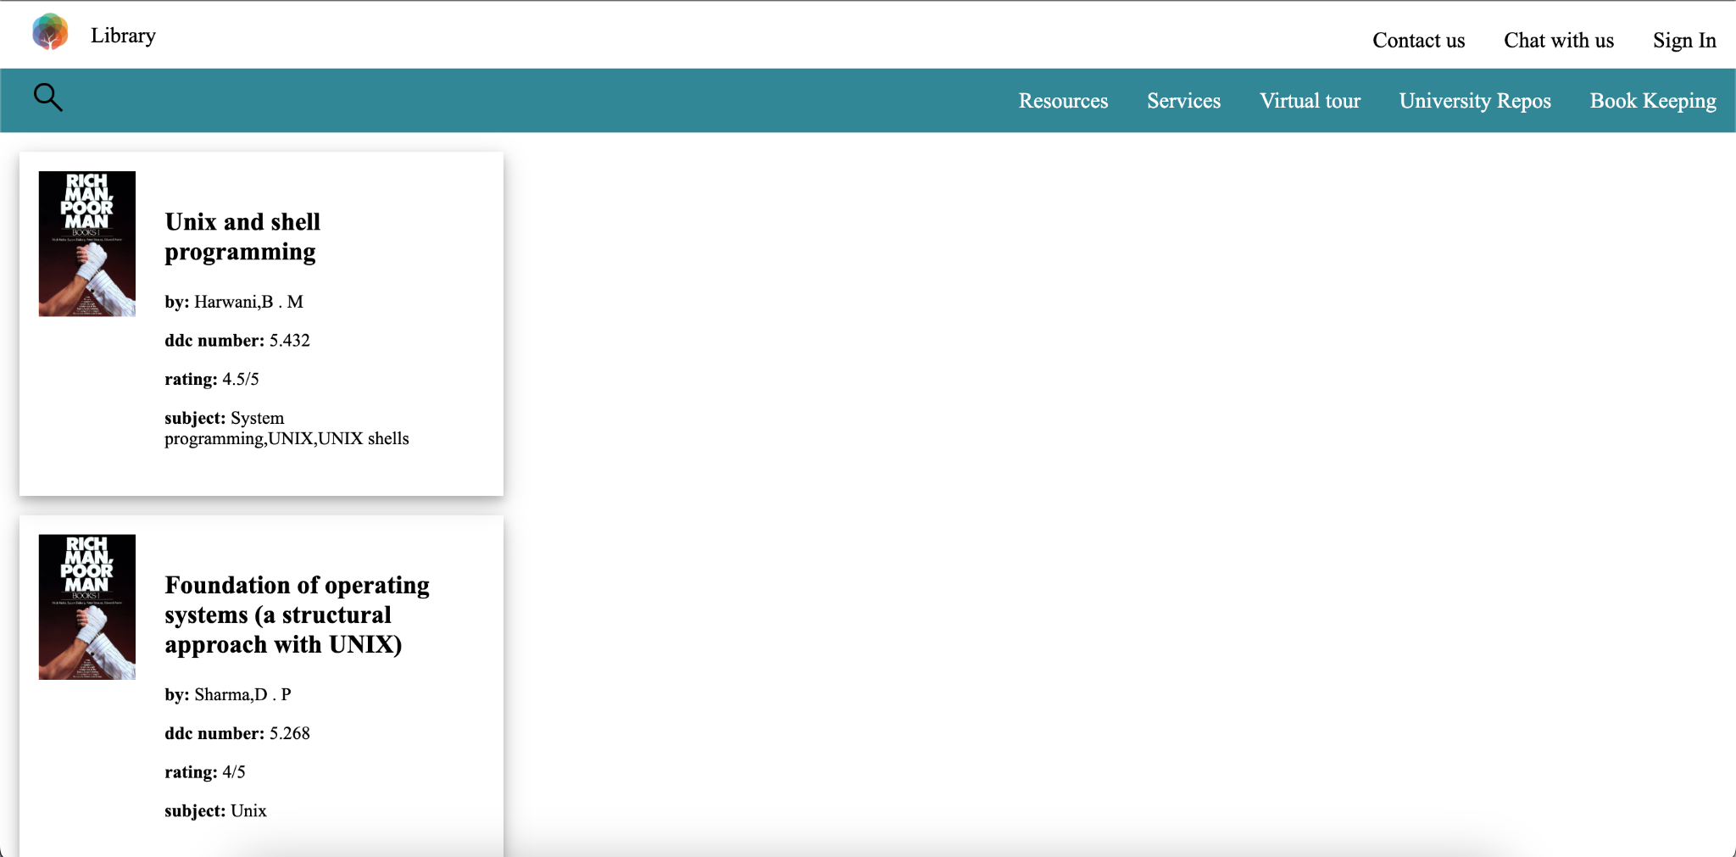

Fig6: Results of searching

This is a implementation of book records for the admin side

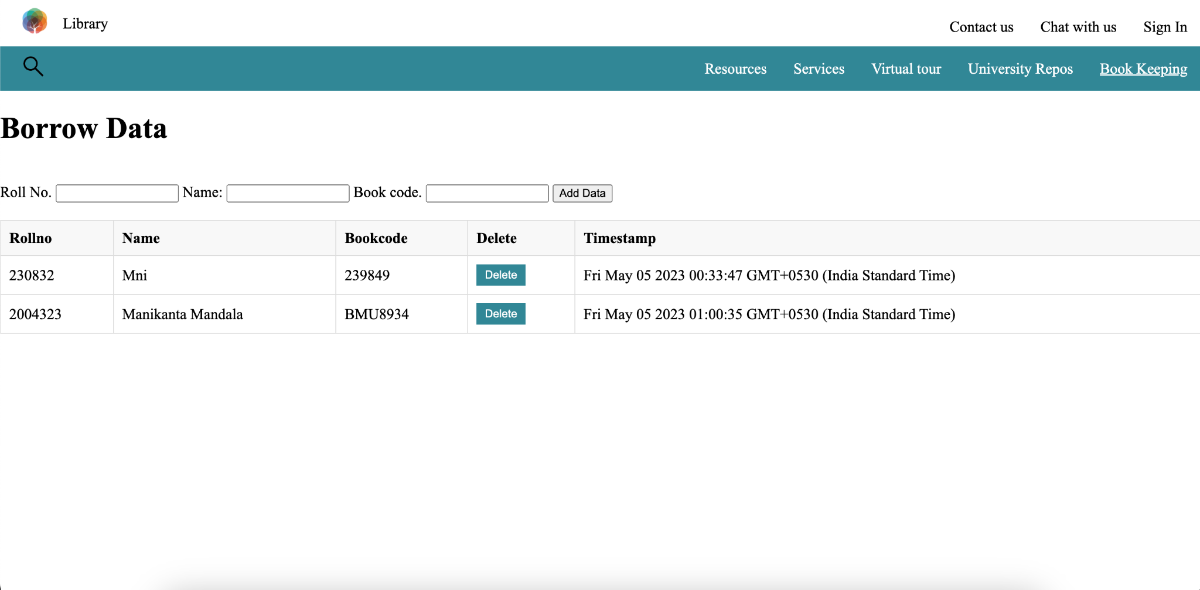

Fig7: book keeping page

This is the User Profile Page personal details section.

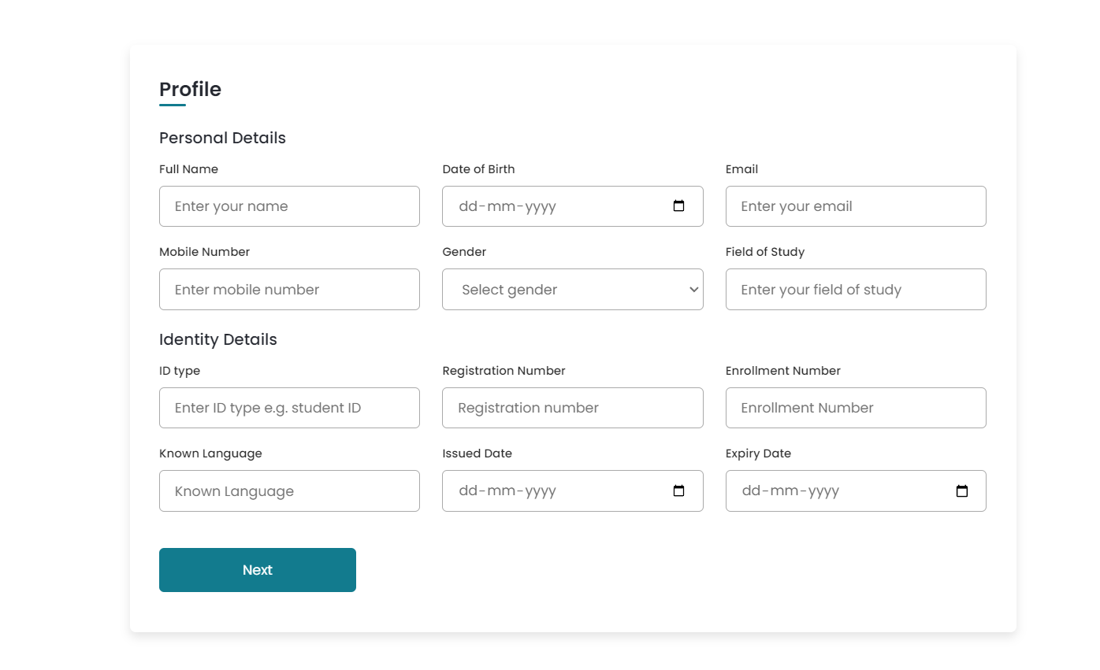

Fig8. Profile Page

This is user profile page address detail section.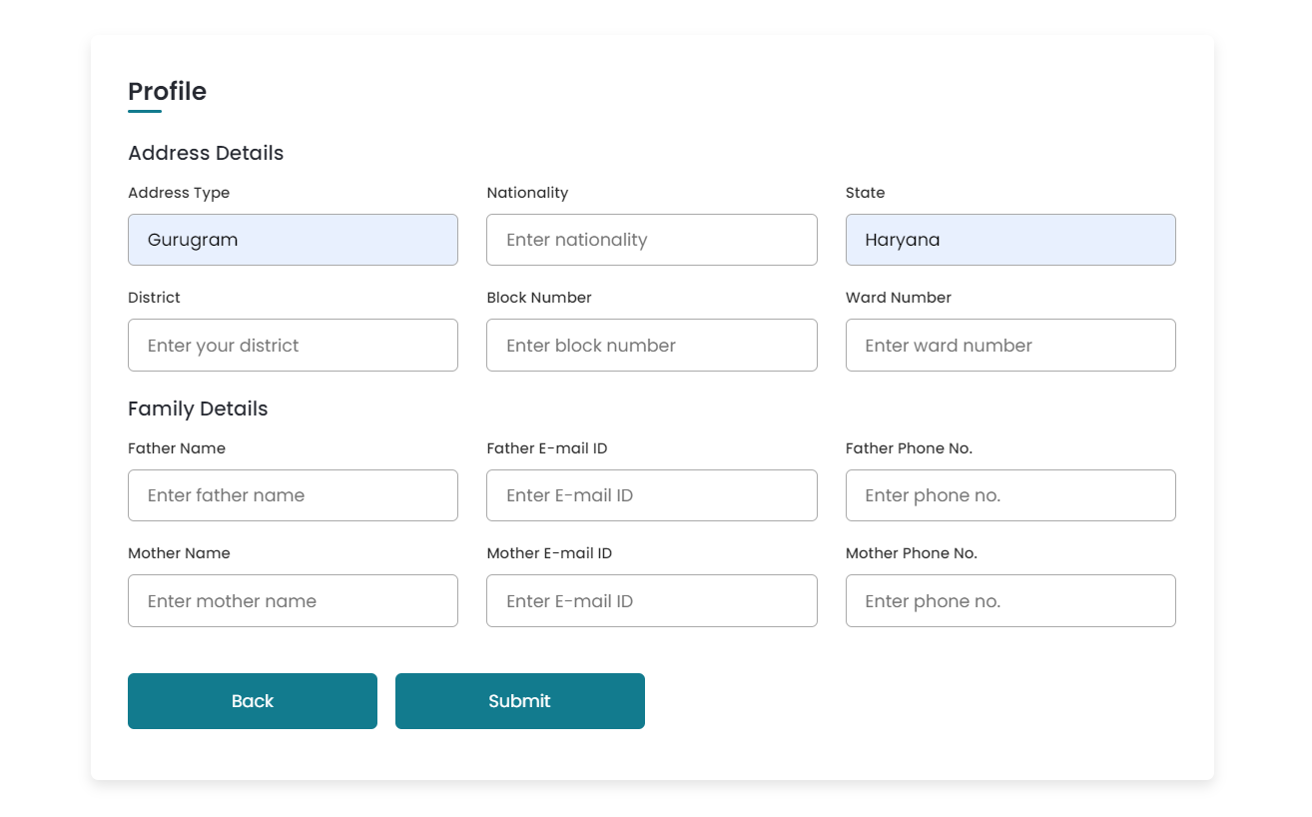

Fig 9. User Profile Page section 2

This is the other implementation called virtual touring. Where users can view the google 360 view photos.

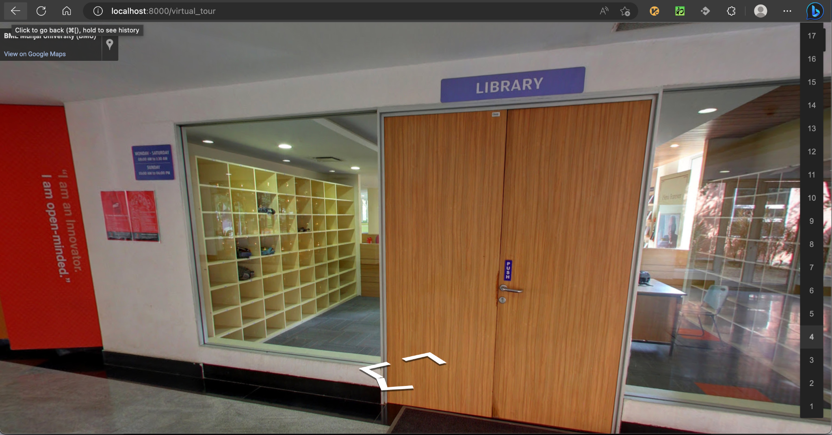

Fig 8: Virtual photos of the library

**6. CONCLUSION AND FUTURE WORK**

A digital library is essential to any institute for its fluidity in functionality and accessibility.

Through this project we learn to implement features that are the core to a digital library website. In this project we tried to implement a partial e library website that is dynamic. The implementation of the website consists of the modules : a navigation bar, a search bar using mongoose and MongoDB, a profile page of the user, a virtual tour of the library page, a bookkeeping page for the admin functions, and a repository page of the college.

For future work, In searching we will implement autocompletion, sorting and filtering after the searching. And we will be integrating this with the remaining website developed by our fellow groups working on the same major project and make it a functional viable e library for our university. The remaining website will consist of the modules like fully functioning sign-in, sign-up page, events page, news page, admin page and so on. With this integration we will get a fully functioning library website as desired and can be considered for real time usage with the help of a maintenance team for our university library. In conclusion, this project is useful real time and has a huge future scope if implemented correctly. The website will be very beneficial real time and hopefully will remove the problems being faced by the current library webpage of the university.

The future scope for an eLibrary project is quite promising as more and more people are turning towards digital resources for their learning and research needs. Here are some potential areas of growth for eLibrary projects:

Increased usage: As the world becomes more digitised, the usage of eLibraries is likely to increase. With the convenience of being able to access resources from anywhere with an internet connection, more and more people are likely to turn to eLibraries for their research needs.

Improved search functionality: With the advent of AI and machine learning, eLibraries are likely to develop more advanced search functionality, which will allow users to find the resources they need more quickly and easily.

Collaboration tools: As eLibraries become more sophisticated, they are likely to include more collaboration tools, such as forums, chat rooms, and other social features, which will allow users to connect and share information with each other.

Personalization: With the help of machine learning and user data, eLibraries are likely to become more personalised, providing users with tailored recommendations based on their interests and reading history.

Integration with other digital platforms: As eLibraries become more integrated with other digital platforms, such as learning management systems and academic databases, they will become an even more central part of the digital learning and research landscape.

Overall, the future scope for eLibrary projects is bright, with many opportunities for growth and innovation in the years to come.

# **6. REFERENCES**

1. <https://libraries.mit.edu>
2. <https://www.lib.cam.ac.uk/>
3. <https://library.stanford.edu/>
4. <https://www.ox.ac.uk/research/support-researchers/information-and-data-services/libraries>
5. <https://library.harvard.edu/>
6. <https://www.library.upenn.edu/>
7. <https://www.library.nd.edu/>
8. <https://library.ithaca.edu/>
9. <https://www.lib.uchicago.edu/>
10. <https://library.caltech.edu/library/home>
11. [http://webopac.iitm.ac.in:8080/search/query?theme=iitm](http://webopac.iitm.ac.in:8080/search/query?facet_item_class=116&sort=dateBookAdded&theme=iitm)
12. <https://library.iitd.ac.in/>
13. <https://www.library.iitb.ac.in/>
14. <https://pkklib.iitk.ac.in/>
15. <https://ndl.iitkgp.ac.in/>
16. [Library of America (loa.org)](https://www.loa.org/)
17. <https://www.spl.org/>
18. <https://www.library.ca.gov/>
19. <https://www.brooklinelibrary.org/>
20. <https://www.carnegielibrary.org/>
21. [EJS -- Embedded JavaScript templates](https://ejs.co/)
22. [Express - Node.js web application framework (expressjs.com)](http://expressjs.com/)
23. [Mongoose v7.1.0: Schemas (mongoosejs.com)](https://mongoosejs.com/docs/guide.html)